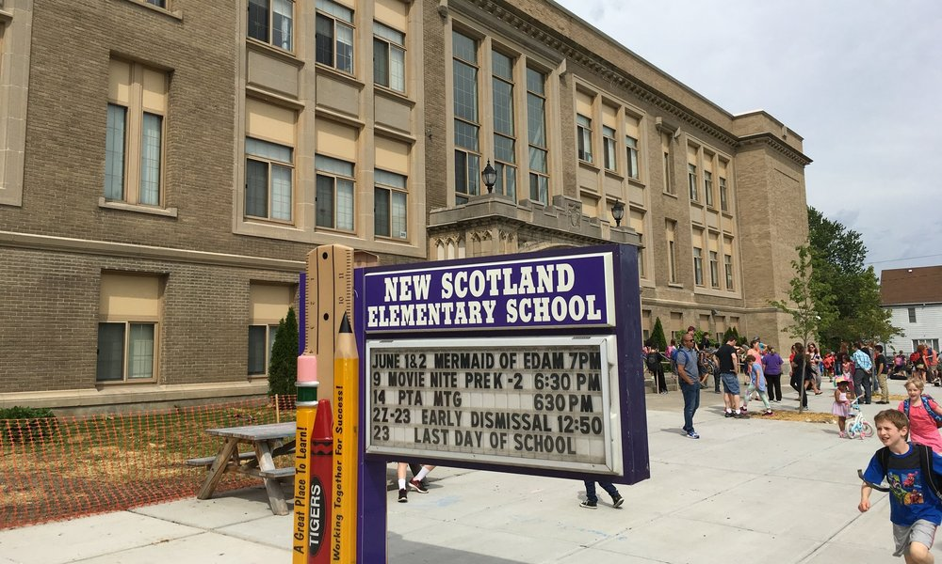

MINIMUM CAPACITY :-

The Minumum intake capacity

of students is between 300-420

children

LIBRARY :-

The Libarary is Available.

CANTEEN:-

The Canteen Facility is Available.

BOARDING :-

No availablility of boarding.

SPORTS :-

There are different categories

sports available.

Girls Volleyball

Boys Volleyball

Football

|  |  |  |
| --- | --- | --- |
| NEW SCOTLAND ELEMENTARY SCHOOL  ALBANY - SCHOOL |  |  |
|  |  |  |
| School Detail :- New Scotland Elementary School is a public school located in Albany, NY, which is in a small city setting. The student population of New Scotland Elementary School is 450 and the school serves PK-5.  The district serves about 9,000 students in 15 schools: 11 elementary schools, three middle schools and Albany High School, a comprehensive high school with a career and technical education center. The district also offers additional innovative academic opportunities for students in support of our vision, mission and goals. |  |
|